Template for Evidence(s)
UI GreenMetric Questionnaire

University : ...
Country : ...
Web Address : …

[7] Governance and Digitalization
SAMPLE
[7.2] University budget for sustainability effort (in US Dollars)

 | 2018 | 2019 | 2020 | Average
Budget Total | $ 500000 | $ 540000 | $ 450000 | $ 496666
Sustainability Budget | $ 130000 | $ 170000 | $ 150000 | $ 150000
 |  |  | Percentage | 30 %

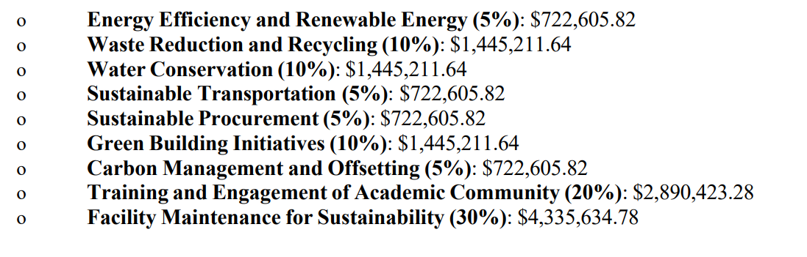
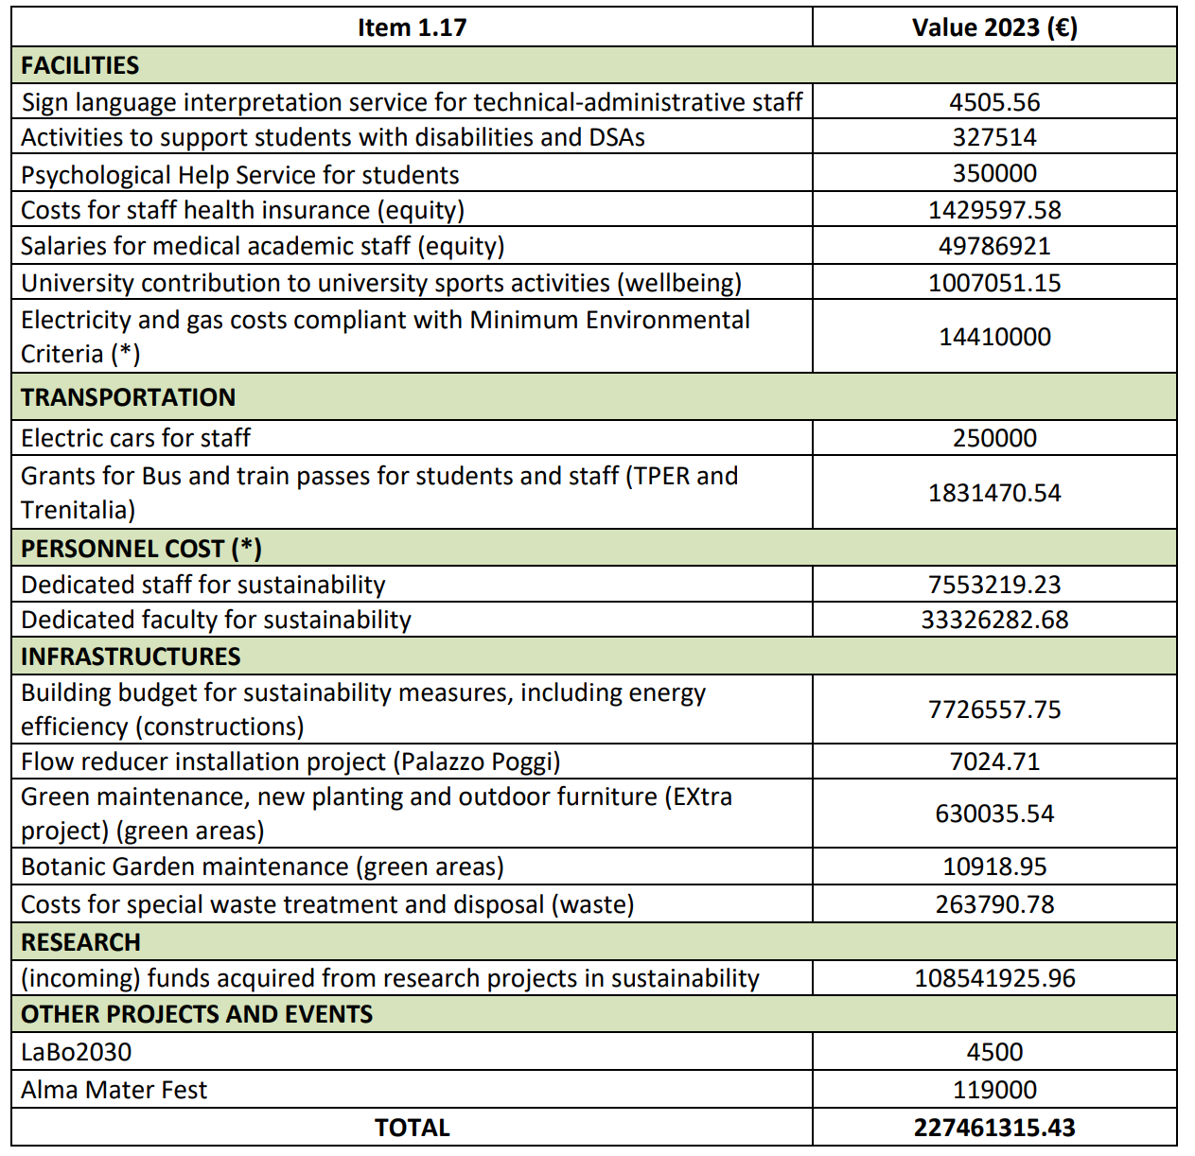

Description:
(Please describe the University budget for sustainability effort in your campus. The following is an example of the description. You can describe more related items if needed.)

- The average percentage university budget for our university is 30%

Additional evidence link (i.e., for videos, more images, or other files that are not included in this file):

